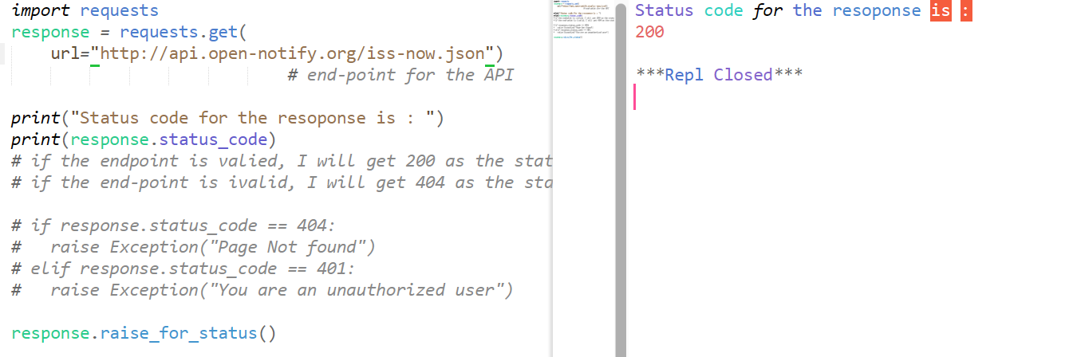



With response.raise_for_status(), the developer knows the status of the end-point along with the exception also, so that we don’t want to specify the exception for the different types of error as we mentioned in if-else

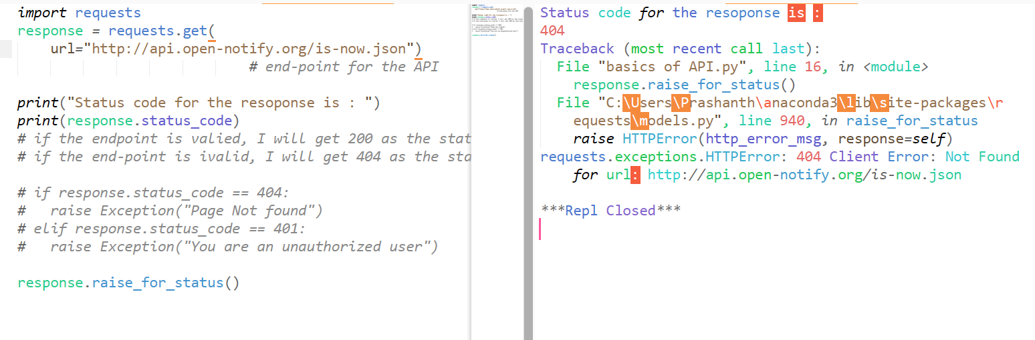



Printing the actual data from the end-point using json

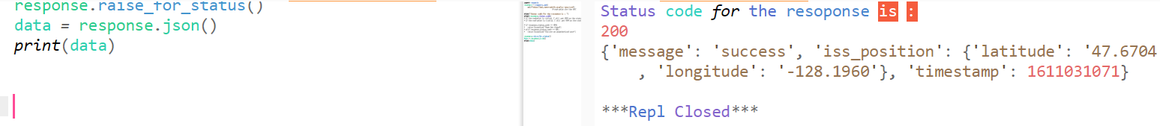

Prints only the key-values of iss_position (i.e slicing the json)

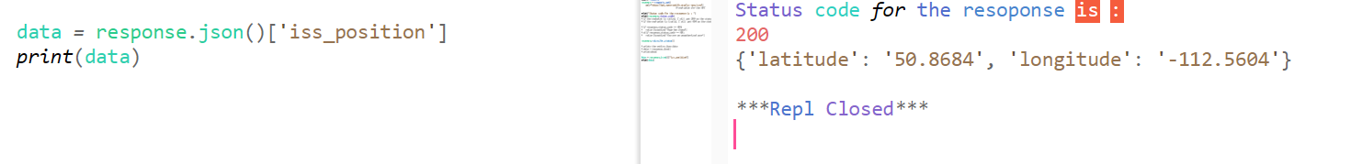

Printing only the longitude by further slicing the iss_position

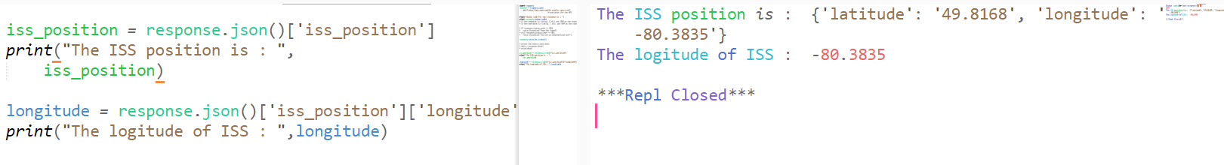

Printing the longitude and latitude data separately

